**Installing AWS CLI with pip3**

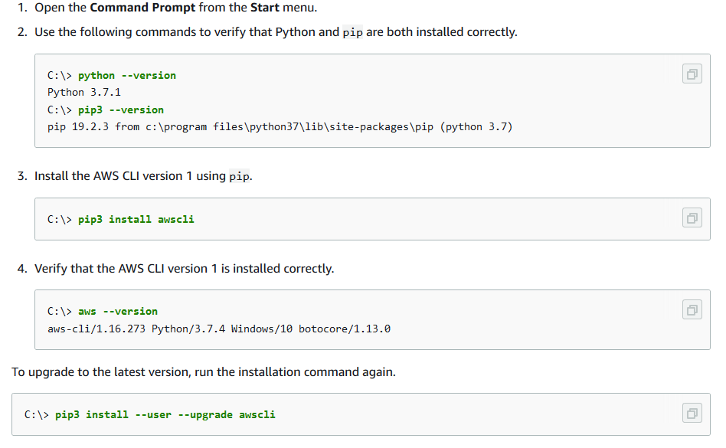

**Configuring AWS CLI**



